**DREAMLAND SECONDARY SCHOOL**

**SINIIYA ESOOKA | OLUSOMA OLW'OKUBIRI**

**NEW SECONDARY LOWER CURRICULUM**

**OBUDDE : Essaawa emu (1hour)**

ERINNYA : .........................................................................................................................

EBIGOBERERWA : Ekibuuzo kino kya buwaze

1. Kitwale nti leero lunaku lwa Ssekukulu era gwe n'abantu bo mwasazewo olunaku luno olukuliza mu kyalo ewa Jjaaja mwe. Buli omu awereddwa omukisa okufumba ekika kyemmere kyasinga okuwomerwa. Nnyonyola mu bujjuvu butya bw'osobola okuteekateeka ekika kyemmere ekyo okuviira ddala ku mutendera ogusooka okutuuka ku lujjuliro.

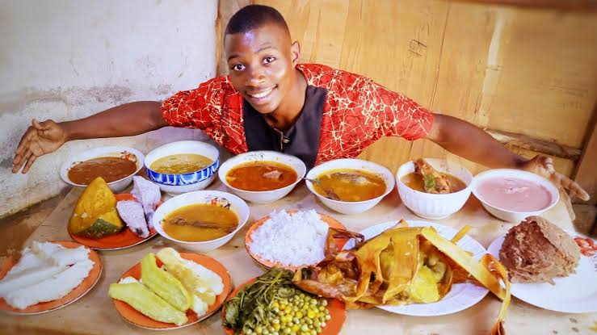

**Bikomye Wano**